# (Pointers)

# QUESTION NO #01

Enter number of value from user to be enter and then find the mean using the pointers.

## Code:

#include <iostream>

using namespace std;

int main(){

int size = 0;

cout << "Enter the number of Values : ";cin >> size ;

float arr[size],float sum=0, * ptr = &arr[0];

for (int a=0;a<size;a++){cout << "Enter the "<<a+1<<" value : ";

cin >> *(a+ptr);sum+= *(a+ptr);}

cout << "Mean is : "<<sum/size;}

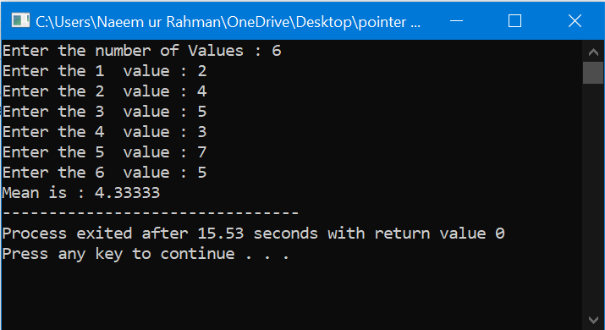

# QUESTION NO #02

Write a program to print a number which is entered from keyboard using pointer.

## Code:

#include <iostream>

using namespace std;

int main(){

cout << "Enter a Number : ";

int n;

cin >> n ;

int* ptr;

ptr = &n;

cout << "Your Entered Number is : "<<*ptr<<endl;

}

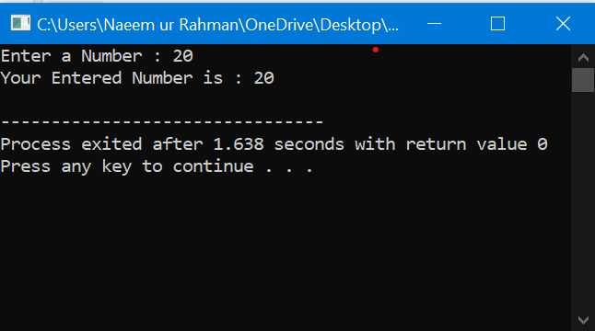

# QUESTION NO #03

Enter array values and get a value form a user and check in array weather it is present or not or use pointer in program.

## Code:

#include <iostream>

using namespace std;

int main(){

int s;

cout << "Enter the Size of Array : ";cin>>s;

int arr[s];

int* ptr;

ptr = &arr[0];

for(int a=0;a<s;a++){

cout << "Enter "<<a+1<<" value : ";

cin>>*(ptr+a);

}

int n,flag=0;

cout << "Enter a Number for search : ";

cin >>n;

for(int a=0;a<s;a++){

if (*(ptr+a)==n){

cout <<*(ptr+a)<< " is at position : "<<a+1<<endl;

flag++;

}

}

if (flag ==0){

cout << "Number "<<n<<" is not in the array "<<endl;

}

return 0;

}

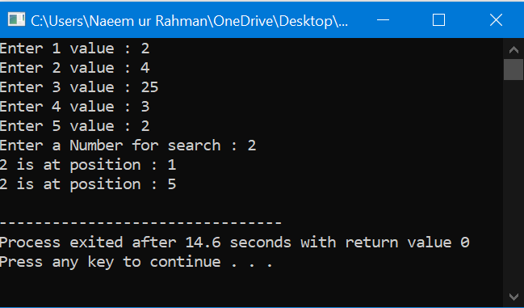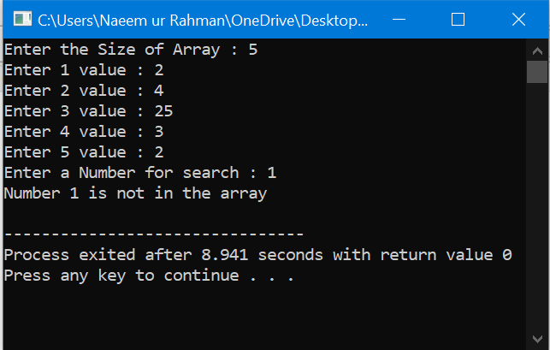

# QUESTION NO #04

Write a function which will take pointer and display the number on screen. Take number from user and print it on screen using that function.

## Code:

#include <iostream>

using namespace std;

void print(int* );

int main(){

int x;

cout << "Enter a Number : ";

cin>>x;

print(&x);

return 0;}

void print (int *ptr){

cout << "Your Enter Number is : "<<*ptr<<endl;

}

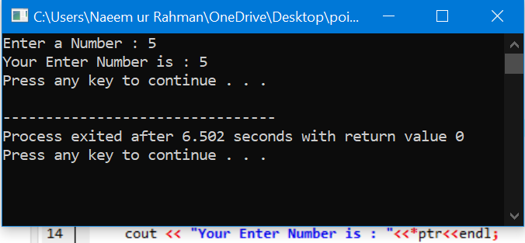

# QUESTION NO #05

Write a program in C++ to add two numbers using pointers.

## Code:

#include <iostream>

using namespace std;

int main(){

int x,y,*xptr,*yptr;

xptr=&x; yptr=&y;

cout << "Enter First Number : "; cin>>*xptr;

cout << "Enter the Second Number : "; cin>>*yptr;

cout << "Sum of Numbers is : "<<*xptr+*yptr<<endl;

system("pause");

return 0;}

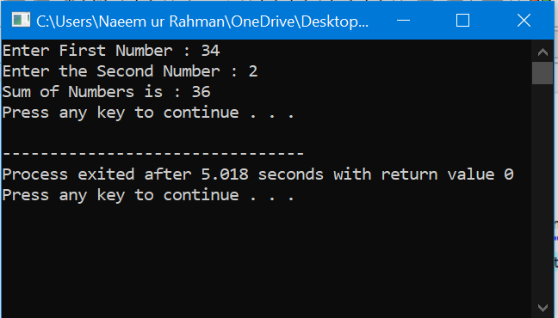

# QUESTION NO #06

Write a program that convert inches to centimeters using the user made function and pass value by pointer.

## Code:

#include <iostream>

using namespace std;

int main(){

void centimeter(double*);

double n;

cout << "Enter the Value in inches : ";

cin>>n;

centimeter(&n);

cout << "Answer in Centimeters : "<<n<<endl;

return 0;

}

void centimeter(double* ptr){

(*ptr)*= 2.54 ;}

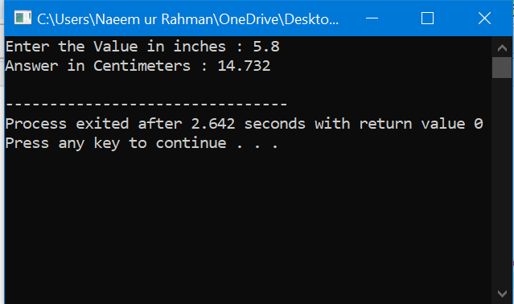

# QUESTION NO #07

Enter value in array and print array both by the user define function and pass array by pointer to the function.

## Code:

#include <iostream>

using namespace std;

void input(int*,int &);

void print(int*,int &);

int main(){

int s;

cout << "Enter the Size of Array : ";

cin>>s;

int arr[s];

input(arr,s);

print(arr,s);

return 0;

}

void input(int* ptr,int&s){

for(int a=0;a<s;a++){

cout << "Enter "<< a+1<< " Value : ";cin>>*(ptr+a);

}

}

void print(int* ptr,int&s){

cout << endl<<"----Array----"<<endl;

for(int a=0;a<s;a++){

cout <<*(ptr+a)<<" ";

}

}

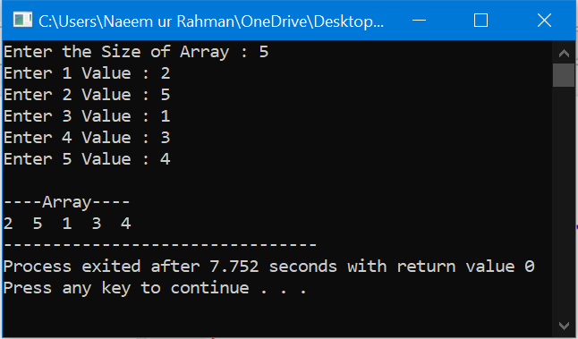

# QUESTION NO #08

Swap the two numbers by using user define swap function and pass variables through pointers.

## Code:

#include <iostream>

using namespace std;

int main(){

void swap(int*,int*);int x, y;

cout << "Enter 1st Number : ";cin>>x;

cout << "Enter 2nd Number : ";cin>>y;

swap(&x,&y);

cout << "After swap ! "<<endl;

cout << "Enter 1st Number : "<<x<<endl;

cout << "Enter 2nd Number : "<<y<<endl;return 0;}

void swap(int* ptr1,int* ptr2){

int t = *ptr1;*ptr1 = *ptr2;*ptr2 = t; }

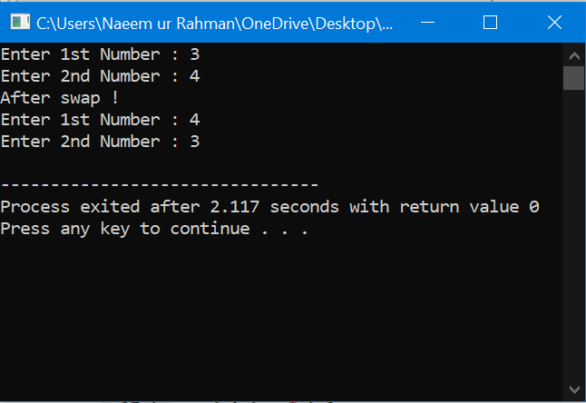

# QUESTION NO #09

Write a program in C++ to print all the alphabets using a pointer

## Code:

#include <iostream>

using namespace std;

int main(){

int s=26;

char arr[s];

char* ptr;

ptr = arr;

for(int a=0;a<s;a++){

*(ptr+a)=a+'A';

}

for(int a=0;a<s;a++){

cout << *(ptr+a)<<" ";

} cout << endl;

return 0; }

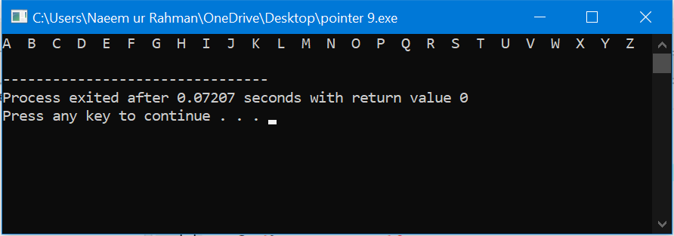

# QUESTION NO #10

Write a C++ program to find the max of an integral data set. The program will ask the user to input the number of data values in the set and each value. The program prints on screen a pointer that points towards max value.

## Code:

#include<iostream>

using namespace std;

int main(){

int s; cout <<"Enter Size :";cin >>s;

cout <<"Enter "<<s<<" values in array "<<endl; int arr[s];

for(int i=0;i<s;i++) {

cin>>arr[i]; }

int max = arr[0];

for(int i=0;i < s;i++){

if (arr[i]>max) max=arr[i]; }

int *ptr = &max ;

cout <<"Largest integer value in the array is "<<*ptr;

return 0;}

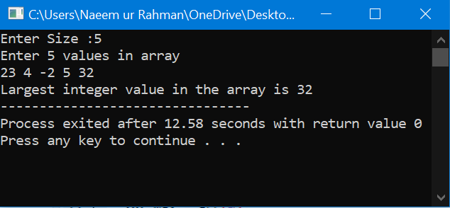

# QUESTION NO #11

A string used as a function argument. The function simply prints the string, by accessing each character in turn

## Code:

#include <iostream>

using namespace std;

int main(){

void display (char*);

char st[] = "Winter is Coming !";

display(st);

return 0;

}

void display(char* ptr){

while (*ptr){

cout << *ptr++; } }

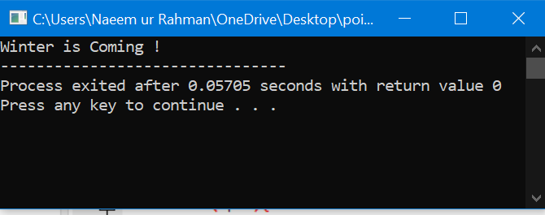

# QUESTION NO #12

Enter a c-string and print through the user define function and pass by pointer reference.

## Code:

#include <iostream>

using namespace std;

int main ()

{

void str(char *);

int s=200;

char string[s];

cout << "Enter the String : ";

cin.getline(string,s);

str(string);

return 0;}

void str(char* str1)

{cout << "String = "<<str1<<endl;}

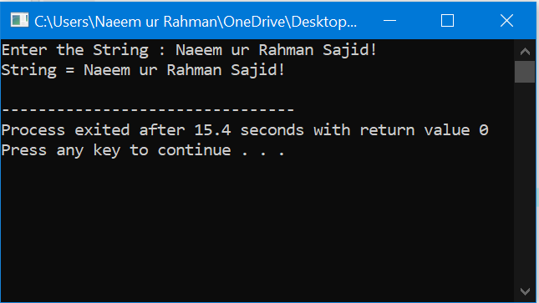

# QUESTION NO #13

Write C++ program to find length of string using pointer.

## Code:

#include <iostream>

using namespace std;

int main() {

int s=100;

char text[s];

char * ptr = text;

int count = 0;

cout<<"Enter a string : ";cin.getline(text,s);

while(*ptr) {

count++; *ptr++;

}

cout<<"Length of string is : "<<count;

return 0;}

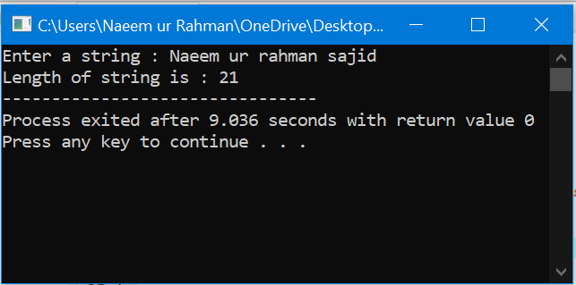

# QUESTION NO #14

Write C++ program to copy one string to another string.

## Code:

#include <iostream>

using namespace std;

int main() {

int s = 200;

char text1[s], text2[s];

char* ptr1 = text1; char* ptr2 = text2;

cout<<"Enter String : ";cin.getline(text1,s);

while(*ptr1){

*(ptr2)++ = *(ptr1)++;}

cout<<"1st String : "<<text1<<endl;;

cout<<"2nd String : "<<text2<<endl; return 0;}

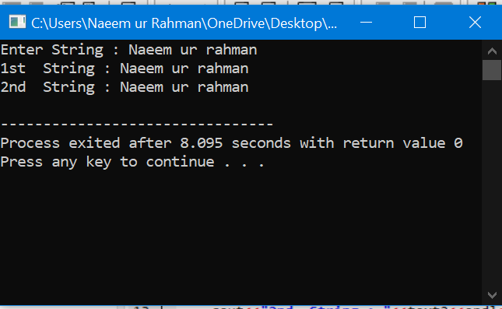

# QUESTION NO #15

Write C++ program to print the elements of the array in reverse order using a pointer

## Code:

#include <iostream>

using namespace std;

int main(){

int s; cout << "Enter the Size : ";cin>>s;

int arr[s], * ptr = arr;

cout<<"Enter "<<s<<" numbers separated by space ! "<<endl;

for (int i=0;i<s;i++){

cin >> *(ptr+i); }

cout<<"Your entered numbers in reverse order are !"<<endl;

for(int i=s-1;i>=0;i--)

cout<<*(ptr+i)<<endl;}

return 0;}

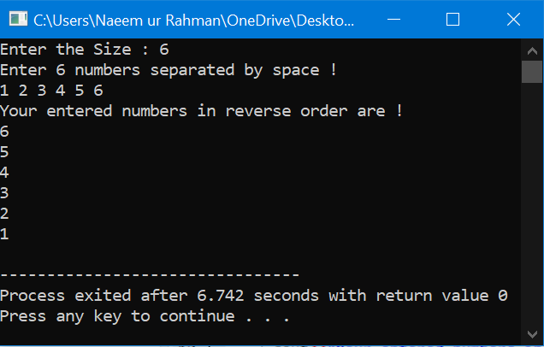

# QUESTION NO #16

Write a C++ program to demonstrate example of structure pointer.

## Code:

#include <iostream>

using namespace std;

struct item

{

char Name[100];

int qty;

float price;

float amount;

};

int main(){

struct item i;

struct item *ptr;

ptr = &i;

cout<<"Enter product name : ";

cin.getline(ptr->Name,100);

cout<<"Enter price : ";

cin>>ptr->price;

cout<<"Enter quantity : ";

cin>>ptr->qty;

ptr->amount = (float) ptr->qty * ptr->price;

cout<<"Product Name : "<<ptr->Name<<endl;

cout<<"Product Price : "<<ptr->price<<endl;

cout<<"Product Quantity : "<<ptr->qty<<endl;

cout<<"Total Amount : "<<ptr->amount<<endl;

return 0;

}

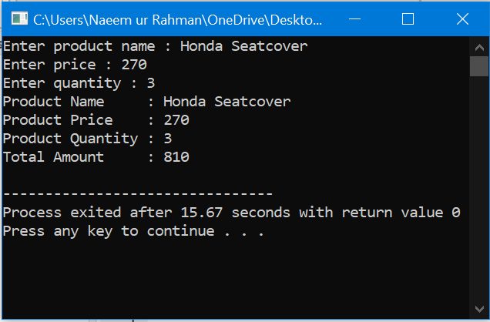

# QUESTION NO #17

Print size of different types Using Pointer in C++.

## Code:

#include <iostream>

using namespace std;

int main(){

int s=300;char str[s];

cout << "Enter the String : ";cin.getline(str,s);

char* ptr;

ptr = str;

int size=sizeof(*ptr);

while(*ptr){ size+=sizeof(*ptr);ptr++;

}

cout << "Size of String is : "<<size;

return 0;

}

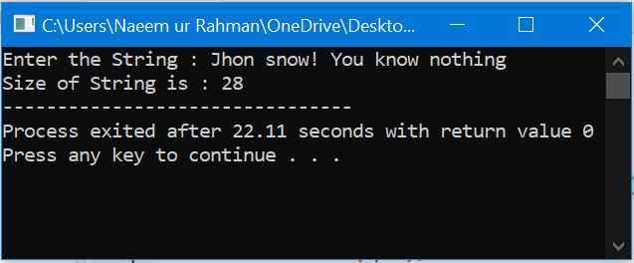

# QUESTION NO #18

Simple Program for Increment and Decrement Integer Using Pointer in C++

## Code:

#include <iostream>

using namespace std;

int main(){

int a, *ptr=&a;

cout << "Enter a Number : ";cin>>a;

cout << "Increment : "<<++(*ptr)<<endl;

cout << "Increment : "<<++(*ptr)<<endl;

cout << "Double Increment : "<<++++(*ptr)<<endl;

cout << "Decrement : "<<--(*ptr)<<endl;

return 0;}

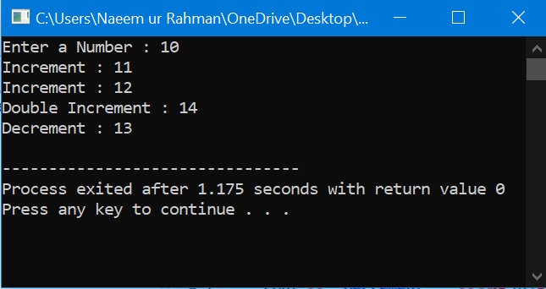

# QUESTION NO #19

Simple Program for Count vowels String Using Pointer in C++

## Code:

#include <iostream>

using namespace std;

int main(){

int s=300,count=0,l=0;char str[s],*ptr=str;

cout << "Enter a String : ";cin.getline(str,s);

while(*ptr){

if(*ptr == 'a' || *ptr == 'e' || *ptr == 'i' || *ptr== 'o' || *ptr == 'u'){

count++;}

l++;ptr++;}

cout << "Length of String is : "<<l<<endl;

cout << "Vowels in String are: "<<count<<endl;return 0;}

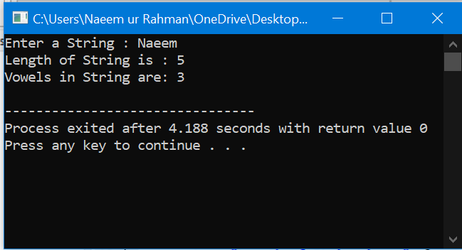

# QUESTION NO #20

Simple Example Program for Area Of Circle Using Pointer In C++

## Code:

#include <iostream>

using namespace std;

int main(){

float area(float*), r;

cout <<"Enter the Radius : ";cin>>r;

cout << "Area of Circle is : "<<area(&r)<<endl;

return 0;

}

float area(float* ptr){

return (*ptr)*(*ptr)*3.14;

}

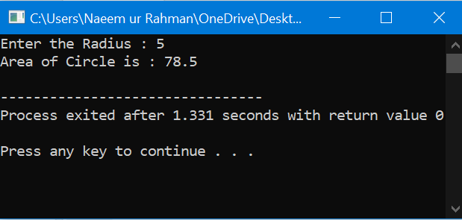

# OOP (Classes)

# QUESTION NO #01

Simple Class Example Program For Find Prime Number In C++

## Code:

#include <iostream>

using namespace std;

class prime{

int a,k;

public: prime(int x){ a=x; }

void check (){ k=0; for(int i=2;i<a;i++){if(a%i==0){ k++; }} }

void result(){

if(k==0){ cout<<a<<" is Prime Nmber "<<endl; }

else{ cout<<a<<" is not Prime Number "<<endl;} }};

int main(){ int n;cout << "Enter a Number : ";cin>>n;prime p = prime(n);p.check();p.result();return 0;}

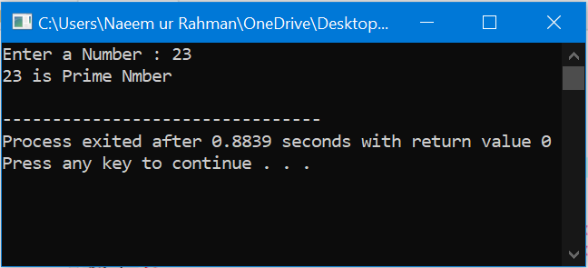

# QUESTION NO #02

Made a user define class calculator and have 4 functions of /, *, +, -and user can tells its choice.

## Code:

#include <iostream>

#include <string>

using namespace std;

class calculate{

float x,y;

public:

calculate(float a,float b){x=a;y=b;}

float sum(){ return x+y; }

float sub(){ return x-y; }

float mul(){ return x*y; }

float div(){ return x/y; }

};

int main(){

float i,j;char c;string ch;

do{

cout << "Enter the x : ";cin>>i;

cout << "Enter the y : ";cin>>j;

cout << "Select the operation *,/,+,- : ";cin>>c;

calculate cl = calculate(i,j);

switch (c){

case '+' : cout << "Addition is : "<< cl.sum()<<endl;break;

case '-' : cout << "Subtraction is : "<< cl.sub()<<endl;break;

case '/' : cout << "Divition is : "<< cl.div()<<endl;break;

case '*' : cout << "Multiply is : "<< cl.mul()<<endl;break;

default : cout << "Wrong Choice ! "<<endl;}

cout << "If you want to use again type 'Yes ' : ";cin>>ch;

}while (ch=="yes");return 0;}

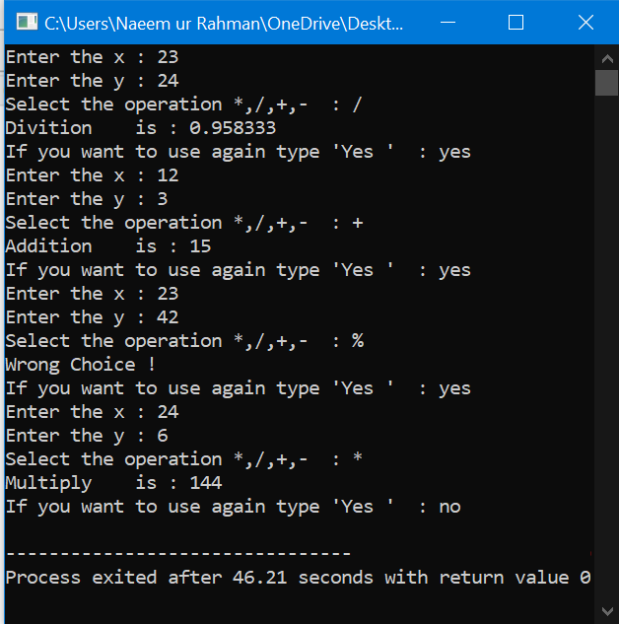

# QUESTION NO #03

Define Constructor in Outside Class Example Program in C++.

## Code:

#include <iostream>

using namespace std;

class Myclass{

int a,b;

public:

Myclass();

void Display(){

cout << "a = : "<<a<<"\t b = : "<<b<<endl;}

};

Myclass::Myclass(){

cout << "In the constructor Outside the Class!"<<endl;

a=12; b=20;}

int main(){

Myclass my; my.Display();}

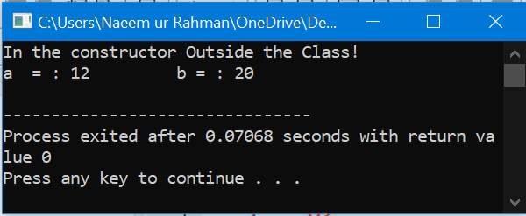

# QUESTION NO #04

Simple Program for Constructor overloading Class Program in C++

## Code:

#include <iostream>

using namespace std;

class Area{

float ans;

public:

Area(){cout << "I am the Constructor with no Arrguments"<<endl;}

Area(float r){ans=3.14*r*r;cout << "Area of Circle is : "<<ans<<endl;}

Area(float x,float y){

ans=x*y;

cout << "Area of Square/Rectangle is : "<<ans<<endl;}};

int main(){

Area a1= Area();Area a2= Area(5);

Area a3= Area(4,6); return 0;}

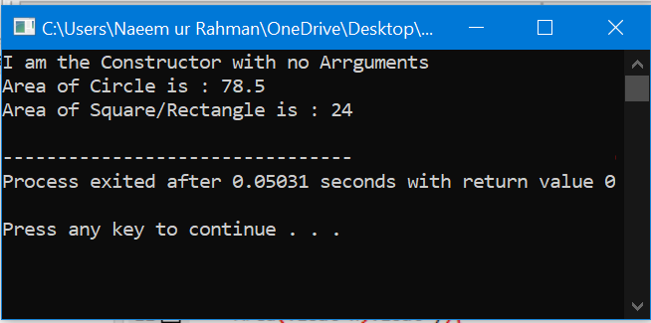

# QUESTION NO #05

Made a function in class which has argument of same class and class is height with values inches and feet.

## Code:

#include <iostream>

using namespace std;

class height{

private :

int feet; float inches;

public :

height() : feet(0),inches(0.0){ }

void get_input(){

cout << "Enter the Height Data !"<<endl;

cout << "Enter Feets : ";cin>>feet;

cout << "Enter Inches : ";cin>>inches; }

void show() {

cout<< "Height is : "<<feet<<'\''<<inches<<'\"'<<endl; }

void add_heights(height,height);

};

void height::add_heights(height a1,height a2)

{

feet =a1.feet+a2.feet;

inches=a1.inches+a2.inches;

if (inches>=12) { inches -=12;feet++; }

}

int main () {

height h1,h2;

h1.get_input();

h2.get_input();

h2.add_heights(h1,h2);

h2.show(); h1.show();

return 0;}

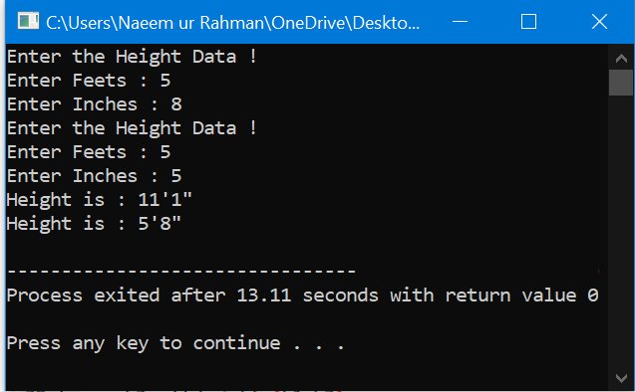

# QUESTION NO #06

Simple Example Program For Destructor In C++

## Code:

#include<iostream>

using namespace std;

class Class

{

public:

Class() {

cout << "Constructor of the BaseClass : Object Created"<<endl;

}

~Class() {

cout << "Destructor of the BaseClass : Object Destroyed"<<endl; }

};

int main (){

Class des; return 0; }

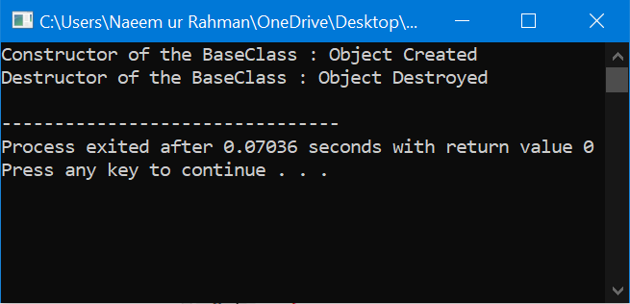

# QUESTION NO #07

Simple Example Program For Copy Constructor In C++

## Code:

#include<iostream>

using namespace std;

class Example { int a, b; public:

Example(int x, int y) { a = x; b = y;

cout << "Im Constructor"<<endl; }

Example(const Example& obj) {

a = obj.a; b = obj.b; cout << "Im Copy Constructor"<<endl; }

void Display() {

cout << "Values : " << a << "\t" << b<<endl; } };

int main() { Example a1(11, 33); Example a2 (a1) ; Example a3 = a1;

a1.Display(); a2.Display();

a3.Display(); return 0; }

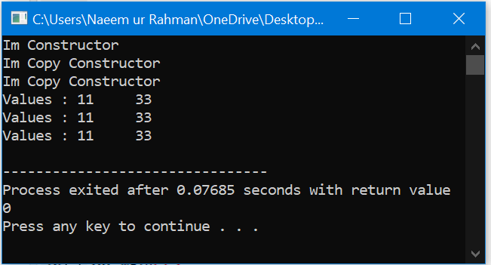

# QUESTION NO #08

Read and Print Student Information Class Example Program In C++

## Code:

#include <iostream>

#include <string>

using namespace std;

class Student {

string name;

int roll, sub1, sub2, sub3;

float total, avg;

public:

void read() {

cout << "Enter Name : "; cin >> name;

cout << "Enter Rollno : "; cin >> roll;

cout << "Enter Marks for Subject 1,2 and 3 : ";

cin >> sub1 >> sub2>> sub3; }

void sum() {

total = sub1 + sub2 + sub3;

avg = total / 3; }

void print() {

cout << "Name : " << name << endl;

cout << "Rollno : " << roll << endl;

cout << "Marks : " << sub1 << " , " << sub2 << " , " << sub3 << endl;

cout << "Total : " << total << endl;

cout << "Average : " << avg << endl; }};

int main() {

Student s1, s2;

cout << "Student 1" << endl;

s1.read(); s1.sum(); s1.print();

cout << "Student 2" << endl;

s2.read(); s2.sum(); s2.print();

return 0; }

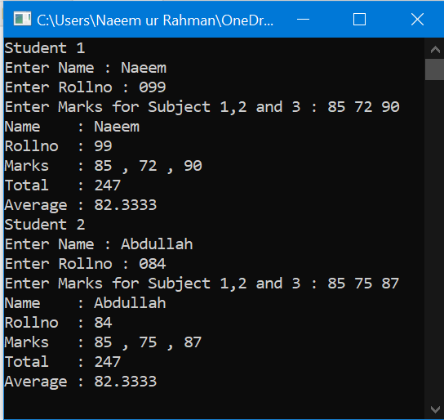

# QUESTION NO #09

Create a class that imitates part of the functionality of the basic data type int. Call the class Int (note different capitalization). The only data in this class is an int variable. Include member functions to initialize an Int to 0, to initialize it to an int value,to display it (it looks just like an int), and to add two Int values. Write a program that exercises this class by creating one uninitialized and two initialized Int values,adding the two initialized values and placing the response in the uninitialized value,and then displaying this result.

## Code:

#include <iostream>

using namespace std;

class Int{

int i;

public:

Int (){ i=0; }

Int (int i1) { i=i1; }

void add(Int a1,Int a2)

{ i=a1.i+a2.i; }

void display()

{

cout << "Value Stored in i = "<<i<<endl;

}

};

int main()

{

int a,b;

cout<<"Enter 1st Integer : ";cin>>a;

cout<<"Enter 2nd Integer : ";cin>>b;

Int Int1(a);

Int Int2(b);

Int Int3;

Int3.add(Int1,Int2);

cout<<"(Int 1) : ";Int1.display();

cout<<"(Int 2) : ";Int2.display();

cout<<"(Int 3) : ";Int3.display();

return 0;}

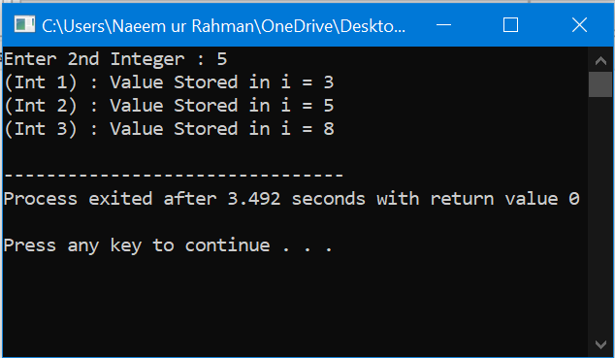

# QUESTION NO #10

Imagine a tollbooth at a bridge. Cars passing by the booth are expected to pay a 50 cent toll. Mostly they do, but sometimes a car goes by without paying. The tollbooth keeps track of the number of cars that have gone by, and of the total amount of money collected.Model this tollbooth with a class called tollBooth. The two data items are a type unsigned int to hold the total number of cars, and a type double to hold the total amount of money collected. A constructor initializes both of these to 0. A member function called payingCar() increments the car total and adds 0.50 to the cash total. Another function, called nopayCar(), increments the car total but adds nothing to the cash total. Finally,a member function called display() displays the two totals.Make appropriate member functions const.Include a program to test this class.This program should allow the user to push one key to count a paying car, and another to count a nonpaying car. Pushing the Esc key should cause the program to print out the total cars and total cash and then exit.

## Code:

#include <iostream>

#include <conio.h>

using namespace std;

const char ESC = 27; const double Toll=0.50;

class tollbooth{

unsigned int car; double amount;

public:

tollbooth():car(0),amount(0){ }

void payingCar() { car++; amount+=Toll; }

void nonpayCar(){ car++; amount+=0; }

void display() const {

cout << "Total Cars Passed : "<<car<<endl;

cout << "Total Amount Collected : "<<amount<<endl; } };

int main() {

char c; tollbooth t;

cout<< "Enter 1 for Paying car "<<endl;

cout<< "Enter 0 for Nonpaying car"<<endl;

cout<< "Enter ESC for Exist Program "<<endl;

do{ cout << "Enter : "; c = getche();

if (c=='1'){ t.payingCar(); }

if (c=='0'){ t.nonpayCar(); } } while(c!=ESC);

t.display(); return 0;}

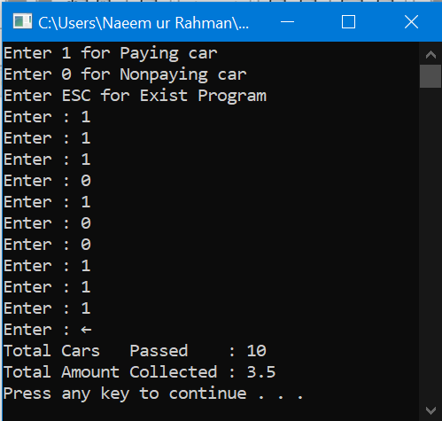

# QUESTION NO #11

Create an employee class, an employee number (type int) and the employee’s compensation (in dollars; type float). Member functions should allow the user to enter this data and display it. Write a main() that allows the user to enter data for three employees and display it.

## Code:

#include <iostream>

#include <iomanip>

using namespace std;

class employee{

int num; float dollar;

public :

employee() : num(0),dollar(0) { }

void input(){

cout<< "Enter Employee Number : ";cin>>num;

cout<< "Enter compensation in $ : ";cin>>dollar; }

void display() {

cout<<setw(20)<<setiosflags(ios::left)<<num<<setw(30)<<setiosflags(ios::left)<<dollar<<endl; } };

void line () {

for (int a=1;a<=40;a++) { cout <<"-"; }

cout<<endl; }

int main () {

employee a,b,c;

a.input(); b.input();

c.input(); line();

cout<<setw(20)<<setiosflags(ios::left)<< "Employee Number "<<setw(30)<<setiosflags(ios::left)<<"Employee Compenstion"<<endl;

line (); a.display();

b.display(); c.display();

line(); return 0; }

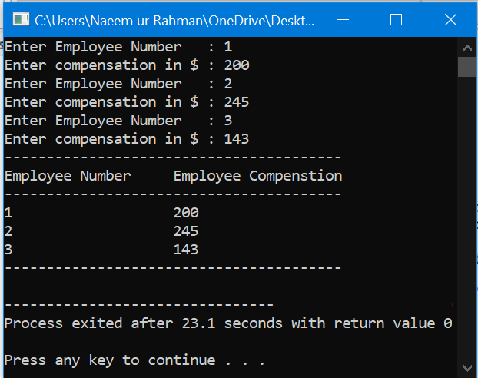

# QUESTION NO #12

Start with the date class. Its member data should consist of three ints: month, day, and year. It should also have two member functions: getdate(), which allows the user to enter a date in 29/01/2021 format, and showdate(), which displays the date.

## Code:

#include <iostream>

using namespace std;

class date{

int year, mounth ,day; char d; public: date () : year(0),mounth(0),day(0) { }

void getdate() { cout << "Enter Date (Day/Mounth/Year) : ";cin>>day>>d>>mounth>>d>>year; }

void showdate() {

cout << "You Entered ! "<<endl;cout<<'\t'<<'\t' << "("<<day<<"/"<<mounth<<"/"<<year<<")"<<endl; } };

int main () { date d1; d1.getdate();

cout << endl; d1.showdate();return 0;}

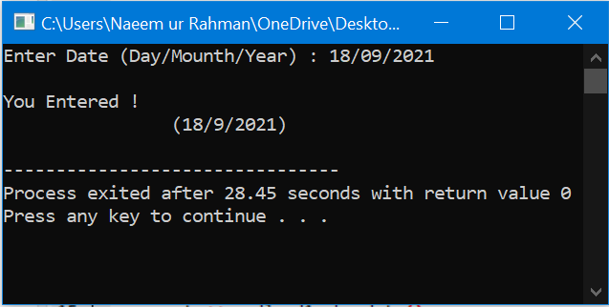

# QUESTION NO #13

C++ Program to find Largest of three Numbers using class.

## Code:

#include<iostream>

using namespace std;

class largest { int x,y,z;

public: void input() {

cout<<"Enter 1st number :: "; cin>>x;

cout<<"Enter 2nd number :: ";cin>>y;

cout<<"Enter 3rd number :: "; cin>>z; } void calc() { int r;

r=((x>y)&&(x>z)?x:(y>x)&&(y>z)?y:z);

cout<<"The Largest Number among [ "<<x<<", "<<y<<", "<<z<<" ] = "<<r<<endl; } };

int main() {

largest g; g.input();

g.calc(); return 0; }

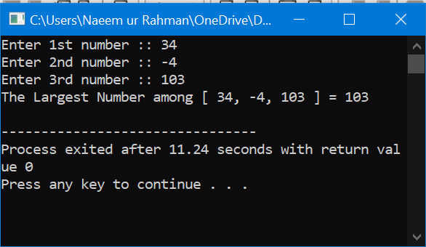

# QUESTION NO #14

C++ program to find Reverse of a Number using class.

## Code:

#include<iostream>

using namespace std;

class rev

{ int n,n1,rn=0,d;

public: void input(); void calc(); void display(); };

void rev::input() {

cout<<"Enter any positive no : ";cin>>n; }

void rev::calc() {

n1 = n; while(n>0) {

d=n%10; rn=(rn*10)+d; n/=10;} }

void rev::display(){ cout<<"Reverse of [ "<<n1<<" ] is : "<<rn<<endl; }

int main () { rev r; r.input();

r.calc(); r.display(); return 0; }

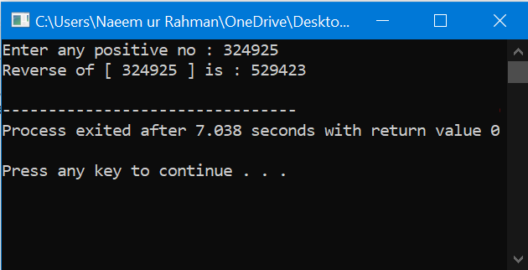

# QUESTION NO #15

C++ program to Add two Complex number passing objects to function

## Code:

#include<iostream>

using namespace std;

class complex

{

int re,im;

public:

void get(){

cout<<"Enter Real Part : ";cin>>re;

cout<<"Enter Imag. Part : ";cin>>im; }

void disp() { cout<<re<<"+"<<im<<"i"<<endl; }

void sum(complex,complex);

};

void complex::sum(complex c1,complex c2) {

re=c1.re+c2.re; im=c1.im+c2.im; }

int main() {

complex c1,c2,c3;

cout<<"Enter 1st complex no. "<<endl;

c1.get();

cout<<"Enter 2nd complex no. "<<endl;

c2.get();

cout<<"The 1st complex no. is : ";

c1.disp();

cout<<"The 2nd complex no. is : ";

c2.disp();

c3.sum(c1,c2);

cout<<"The Sum of two complex no.s are : ";

c3.disp();

return 0;

}

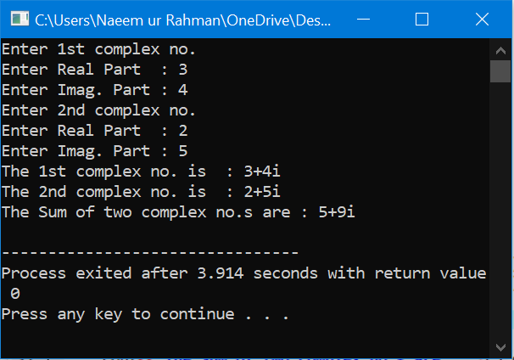

# QUESTION NO #16

Write a C++ Program to find Sum of odd numbers between 1 and 100 using class

## Code:

#include<iostream>

using namespace std;

class sum {

int n,s=0;

public:

void calc(); void display(); };

void sum::calc(){

for(n=1;n<=100;n+=2)

s+=n; }

void sum::display() {

cout<<"Sum of all odd numbers between 1-100 : "<<s; }

int main() {

sum s;

s.calc();

s.display(); }

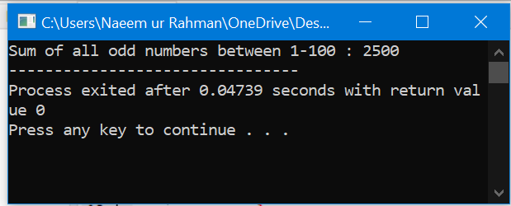

# QUESTION NO #17

C++ Program to Print Numbers from 1 to n using class

## Code:

#include<iostream>

using namespace std;

class Num{

public:

static int i;

Num(){

cout<<i++<<" "; }

};

int Num::i=1;

int main(){

int n;

cout<<"Enter value on n : ";cin>>n;

Num obj[n];

cout << endl;

return 0; }

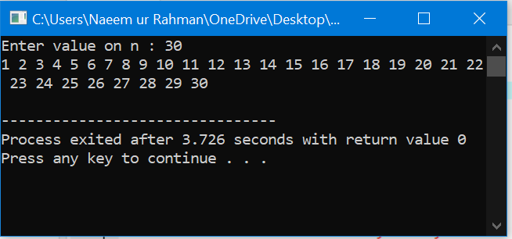

# QUESTION NO #18

C++ Program to calculate Volume of Cube using constructor

## Code:

#include<iostream>

using namespace std;

class cube{

public:

double side;

double volume() {

return(side*side*side); }

cube(double side1){

cout << "A constructor is called" << endl;

side=side1;

}

cube(){

cout << "A default constructor is called " << endl;

}

~cube(){

cout << "Destructing " << side << endl;

}

};

int main() {

cube c1(2.34);

cube c2;

cout << "The side of the cube is: " << c1.side << endl;

cout << "The volume of the first cube is : " << c1.volume() << endl;

cout << "Enter the length of the second cube : " ;

cin >> c2.side;

cout << "The volume of second cube is : " << c2.volume() << endl;

return(0);

}

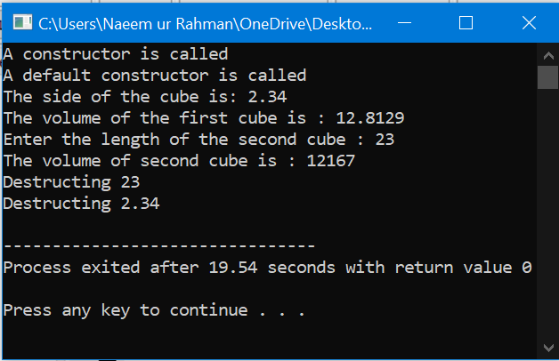

# QUESTION NO #19

Write a C++ Program to Display Date using Constructors

## Code:

#include<iostream>

using namespace std;

class date{

int dd, mm, yy;

public:

date(){

dd=19;

mm=9;

yy=2021;

cout<<"Date Object has been created......."<<endl; }

void display() { cout<<"The Entered Date is : "<<dd<<"-"<<mm<<"-"<<yy<<"\n"; } };

int main (){

date d; d.display (); return 0; }

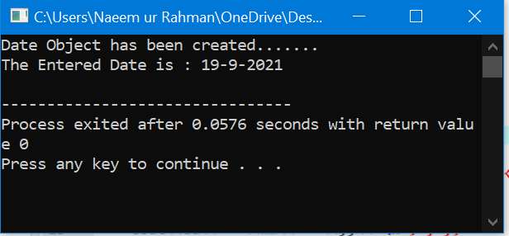

# QUESTION NO #20

Write a C++ Program To Calculate Electricity Bill Of Person using Class

## Code:

#include<iostream>

using namespace std;

class bill{

int no;

char name[20];

int units;

double bill;

public:

void get(){

cout<<"Enter Details of Customer Below " <<endl;

cout<<"Enter Customer No. : ";cin>>no;

cout<<"Enter Customer Name : ";cin>>name;

cout<<"Enter No. of Units used : "; cin>>units; }

void put() {

cout<<"Entered Details of Customer are : " <<endl;

cout<<"Customer No. is : "<<no<<endl;

cout<<"Customer Name is : "<<name<<endl;

cout<<"Number of Units Consumed : "<<units<<endl;

cout<<"Bill of Customer : "<<bill<<endl; }

void calc_bill(){

if(units<=100) bill=units*1.20;

else if(units<=300) bill=100*1.20+(units-100)*2;

else bill=100*1.20+200*2+(units-300)*3; } };

int main() {

bill b1; b1.get();

b1.calc_bill(); b1.put();

return 0;

}

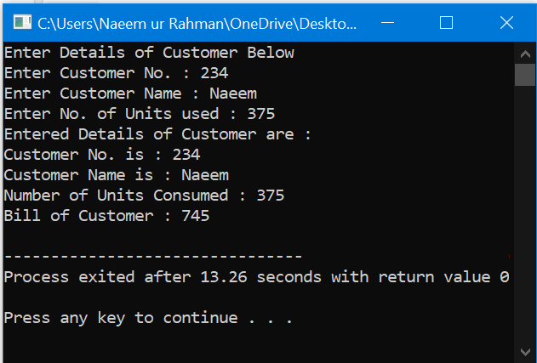

# (Arrays)

# QUESTION NO #01

C++ Program to Remove Characters in String Except Alphabets.

## Code:

#include <iostream>

using namespace std;

int main() {

string line; int i;

cout << "Enter any string : "; cin>>line;

cout << "The Original String is : " << line<<endl; int len = line.size();

for(i=0;i<len;++i) {

if (!((line[i]>='a' && line[i]<='z') || (line[i]>='A' && line[i]<='Z'))) {

line[i]='\0'; } }

cout << "After Removing Characters, String is :: " << line<<endl;

return 0; }

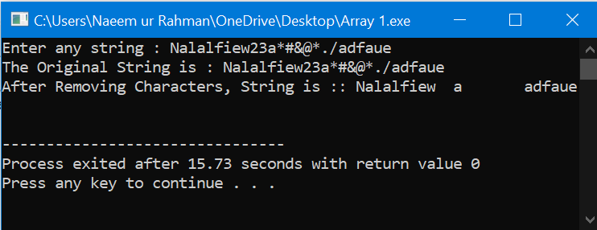

# QUESTION NO #02

Write a C++ Program to find Largest Element in an Array

## Code:

#include <iostream>

using namespace std;

int main(){

int s;cout << "Enter the size of Array : ";cin>>s;

int arr[s],max;

for(int a=0;a<s;a++){

cout << "Enter : ";cin>>arr[a]; }

max=arr[0];

for(int a=0;a<s;a++){

if(max<arr[a]){ max=arr[a]; } }

cout << "Max Number is : "<<max<<endl;

return 0; }

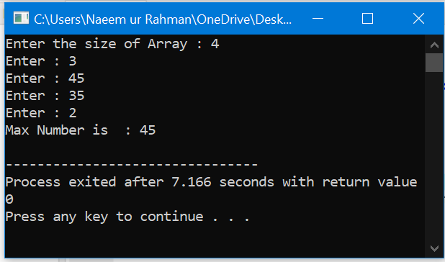

# QUESTION NO #03

C++ Program to Reverse an Array using functions

## Code:

#include <iostream>

using namespace std;

void Reverse_Array(int array[],int size);

int main() {

int i,size;

cout<<"Enter array size : "; cin>>size;

int a[size];

for(i=0; i<size; i++) {

cout<<"Enter arr["<<i<<"] Element : "; cin>>a[i];

}

cout<<"Stored Data in Array : "<<endl;

for(i=0;i<size;i++) {

cout<<" "<<a[i]<<" ";

}

Reverse_Array(a,size);

cout<<endl << "Reversed Array Values are : " <<endl;

for(i=0;i<size;i++) {

cout<<" "<<a[i]<<" ";

}

cout<<endl;

return 0;

}

void Reverse_Array(int array[],int size){

int temp; size--;

for (int i=0;size>=i;size--,i++) {

temp=array[i];

array[i]=array[size];

array[size]=temp;

}

}

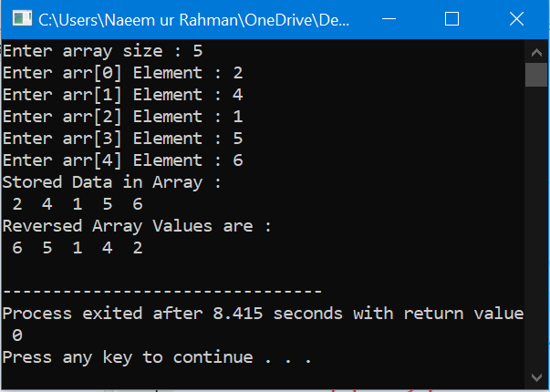

# QUESTION NO #04

Write a C++ Program to Sort Array Elements in Ascending order.

## Code:

#include<iostream>

using namespace std;

int main() {

int i,j,temp,size;

cout<<"Enter array size : "; cin>>size;

int a[size];

for(i=0; i<size; i++){

cout<<"Enter arr["<<i<<"] Element : ";cin>>a[i]; }

cout<<"Stored Data Before Sorting In Array "<<endl;

for(i=0;i<size;i++) {

cout<<" "<<a[i]<<" "; }

for(i=0;i<size;i++){

for(j=0;j<size-i-1;j++) {

if(a[j]>a[j+1]) {

temp=a[j]; a[j]=a[j+1]; a[j+1]=temp;} } }

cout<<endl<<"Stored Data After Sorting In Array \n";

for(i=0;i<size;i++) {

cout<<" "<<a[i]<<" "; }

cout<<endl; return 0;}

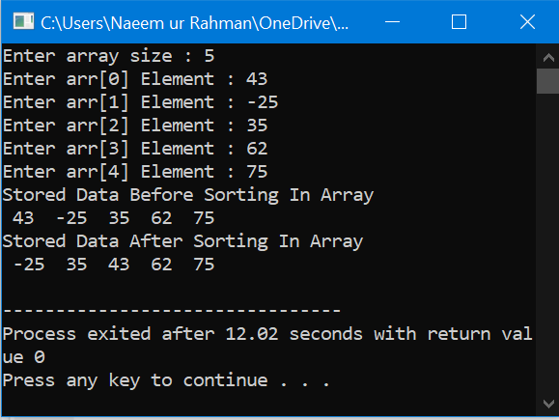

# QUESTION NO #05

C++ Program to Find Sum of Elements of an Array

## Code:

#include <iostream>

using namespace std;

int main(){

int s,sum=0;

cout << "Enter Size : ";cin>>s;

int arr[s];

for (int i=0;i<s;i++){

cout << "Enter : ";cin>>arr[i];

sum+=arr[i];}

cout<< "Sum is : "<<sum<<endl;

return 0;}

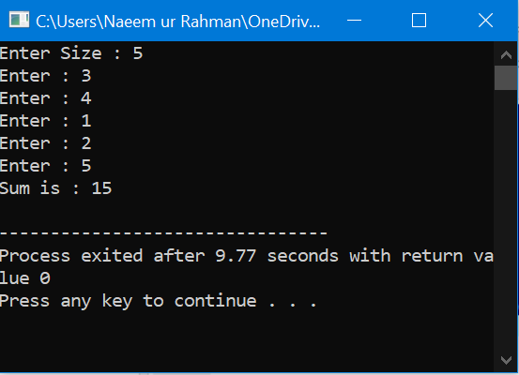

# QUESTION NO #06

C++ Program to Find Even and Odd Numbers using array

## Code:

#include<iostream>

using namespace std;

int main(){

int size; cout<<"Enter array size : ";cin>>size;

int arr[20],even[20],odd[20],j=0,k=0;

for(int i=0; i<size; i++)

{

cout<<"Enter arr["<<i<<"] Element : "; cin>>arr[i];

}

cout<<"Stored Data in Array "<<endl;

for(int i=0;i<size;i++) { cout<<" "<<arr[i]<<" ";

}

for(int i=0; i<size;i++) {

if(arr[i]%2==0) { even[j]=arr[i]; j++;

}

else { odd[k]=arr[i]; k++; } }

cout<<endl<<"Even Elements in Array are "<<endl;

for(int i=0; i<j ;i++){ cout<<" "<<even[i]<<" ";

}

cout<<endl<<"Odd Elements in Array are "<<endl;

for(int i=0; i<k; i++) { cout<<" "<<odd[i]<<" ";

}

return 0;

}

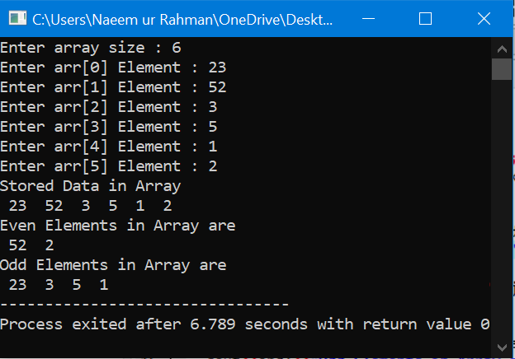

# QUESTION NO #07

C++ Program to Delete an element in an array at desired position

## Code:

#include<iostream>

using namespace std;

int main()

{

int size;cout<<"Enter array size : ";

cin>>size;

int i,a[size],no,pos;

for(i=0; i<size; i++){

cout<<"Enter arr["<<i<<"] Element : ";cin>>a[i];

}

cout<<endl<<"Stored Data in Array : "<<endl;

for(i=0;i<size;i++){cout<<" "<<a[i]<<" ";

}

cout<<endl<<"Enter position to Delete number : ";cin>>pos;

if(pos>size){

cout<<"This is out of range.";

}

else{ --pos;

for(i=pos;i<=size-1;i++){

a[i]=a[i+1];

}

cout<<"New Array is : "<<endl;

for(i=0;i<size-1;i++){

cout<<" "<<a[i]<<" ";

}

}

cout<<endl;

return 0;

}

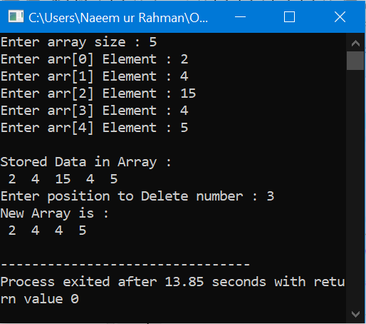

# QUESTION NO #08

C++ Program to Insert an element in an array at specific position

## Code:

#include<iostream>

using namespace std;

int main() {

int size;

cout<<"Enter array size : "; cin>>size;

int i,a[size],no,pos;

for(i=0; i<size; i++) {

cout<<"Enter arr["<<i<<"] Element :: "; cin>>a[i];

}

cout<<"\nStored Data in Array \n";

for(i=0;i<size;i++) {

cout<<" "<<a[i]<<" ";

}

cout<<"\nEnter position to insert number : "; cin>>pos;

if(pos>size) {

cout<<"This is out of range.";

}

else {

cout<<"Enter number to be inserted : ";

cin>>no;

--pos;

for(i=size;i>=pos;i--) { a[i+1]=a[i]; }

a[pos]=no;

cout<<"New Array is :\n";

for(i=0;i<size+1;i++) { cout<<" "<<a[i]<<" ";

}

}

cout<<"\n";

return 0;

}

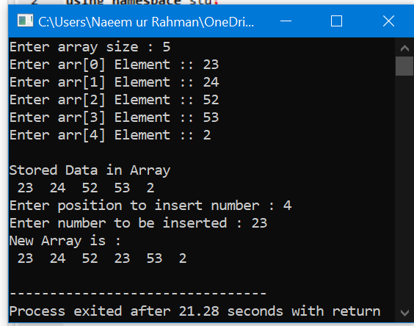

# QUESTION NO #09

Write a C++ Program to Pass an array in a function

## Code:

#include <iostream>

using namespace std;

void pass(int[],int);

int main() {

int a[]={1,2,3,4,5}; pass(a,5);

return 0; }

void pass(int b[],int n){

int i;

for(i=0;i<n;i++){

cout<<"\n"<<b[i];

}

}

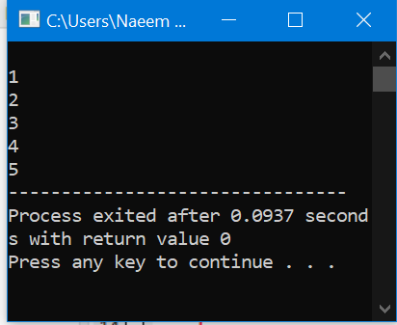

# QUESTION NO #10

Write a C++ Program for Three Dimensional Array Example

## Code:

#include<iostream>

using namespace std;

int main()

{

int arr[3][4][2] =

{ { {2, 4}, {7, 8}, {3, 4}, {5, 6} },

{ {7, 6}, {3, 4}, {5, 3}, {2, 3} },

{ {8, 9}, {7, 2}, {3, 4}, {5, 1} } };

cout<<"arr[0][0][0] = "<<arr[0][0][0]<<"\n";

cout<<"arr[0][2][1] = "<<arr[0][2][1]<<"\n";

cout<<"arr[2][3][1] = "<<arr[2][3][1]<<"\n";

return 0;}

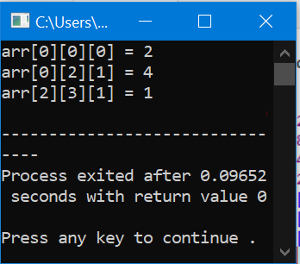

# QUESTION NO #11

C++ Program to find Average of n Numbers using array

## Code:

#include <iostream>

using namespace std;

int main(){

int n, i; float a[100], sum=0.0 , average;

cout<<"Enter size of Array: ";cin>>n;

for(i=0;i<n;++i) {

cout<<"Enter "<<i+1<<" element : "; cin>>a[i];

sum += a[i]; }

average = sum / n;

cout << "Average of "<<n<<" Numbers is = " << average<<"\n";

return 0;}

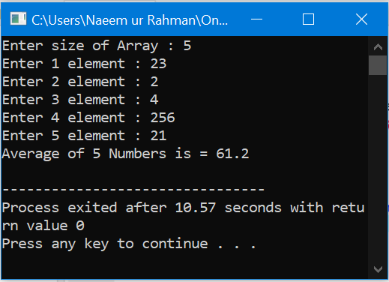

# QUESTION NO #12

C++ Program to Accessing Elements of an Array Using Pointer

## Code:

#include <iostream>

using namespace std;

int main(){

int a[100],n,i;

cout<<"Enter size of Array : ";cin>>n;

for(i=0;i<n;++i) {

cout<<"Enter "<<i+1<<" element : ";cin>>a[i]; }

cout << "Accessing Elements through Pointers are \n";

for(int i = 0; i < n; ++i) {

cout << endl << *(a + i); }

return 0;}

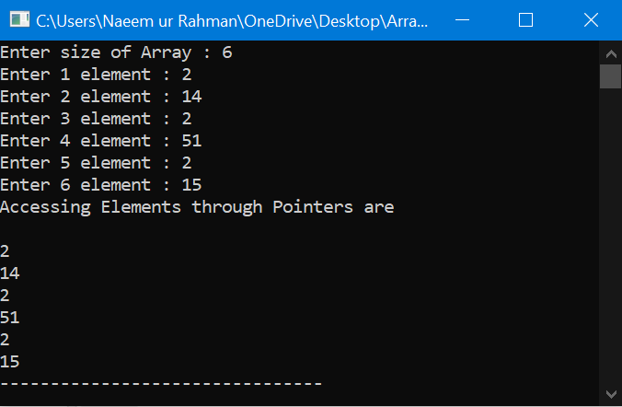

# QUESTION NO #13

Sort the array and find the median of array list

## Code:

#include <iostream>

using namespace std;

void mediean (float[],int);

int main ()

{

int a;

cout << "Enter the Number of Values : ";cin>>a;

const int size = a;

float array[a];

mediean (array,a);

return 0;

}

void mediean (float a[],int b)

{

float m = 0 ;

for (int x=0;x<b;x++)

{

cout << x+1 << " Enter : " ; cin>>a[ x ];

}

cout <<endl;

for (int x=0;x<b-1;x++)

{

for (int y=0;y<b-1;y++)

{

if (a[y]>a[y+1])

{

int t;

t= a[y];

a[y]=a[y+1];

a[y+1]=t;

}

}

}

cout << " IN ORDER "<<endl;

for (int y=0;y<b;y++)

{

cout << a[y]<<" ";

}

cout <<endl;

if (b%2!=2)

{

m = a[b/2];

}

else

{

m = ( ( a [ ( b-1 ) / 2 ] + a[ b / 2 ] ) / 2 );

}

cout <<"Mediean is : "<< m << endl;

}

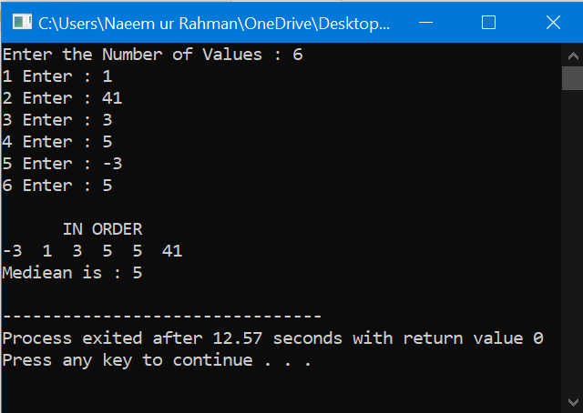

# QUESTION NO #14

Find minimum and maximum number both and sort the array also.

## Code:

#include <iostream>

using namespace std;

int main(){

int b,A[b],min = INT_MAX,max=INT_MIN;

cout << "Enter the number of inputs : ";cin>>b;

cout << "Enter values "<<endl;

for (int a=0;a<b;a++){cin>>A[a];

if (max < A[a]){max = A[a];}

if (min > A[a]){min = A[a];}}

cout << "The samllest value is : "<<min<<endl;

cout << "The largest value is : "<<max<<endl;return 0;}

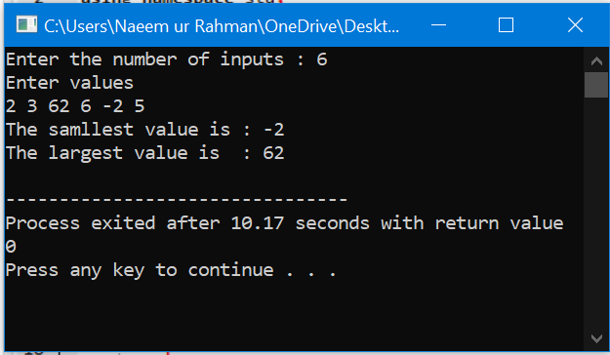

# QUESTION NO #15

Array swaping.

## Code:

#include <iostream>

using namespace std;

int main (){

int A[3]={1,2,3};int B[3]={4,5,6};

int s;for(int c=0;c<3;c++){

s=A[c];A[c]=B[c];B[c]=s;}

cout << "Values in A After Swaping are "<<endl;

for (int a=0;a<3;a++){

cout << A[a]<<" ";}cout << endl;

cout << "Values in B After Swaping are "<<endl;

for (int b=0;b<3;b++){

cout <<B[b]<<" ";}

return 0;}

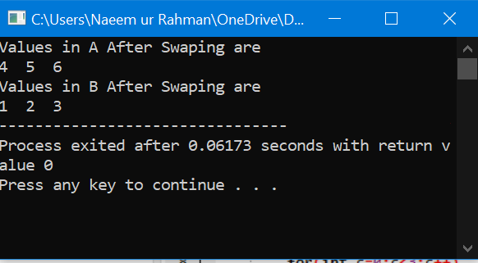

# QUESTION NO #16

Frequency of values in array.

## Code:

#include <iostream>

using namespace std;

int main ()

{

int check[6]={0},i;

cout << "Enter no of Inputs : ";cin >>i;

int A[i];

for(int a=0;a<i;a++)

{

cout << "Enter the value : ";cin>>A[a];cout <<endl;

}

for (int a=0;a<i;a++)

{

if (check[a]==1)

{

continue ;

}

int count =1;

for (int b=a+1;b<i-1;b++)

{

if (A[a]==A[b])

{

check[b]=1;

count++;

}}

cout << "Frequency of "<<A[a]<<" is : " << count <<endl;

}

return 0;}

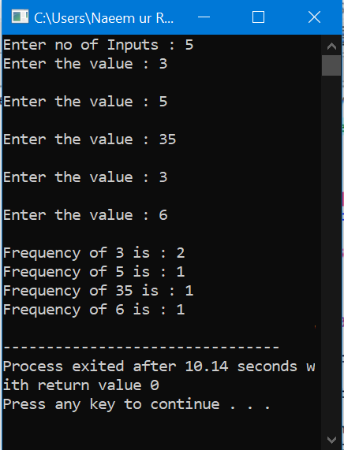

# QUESTION NO #17

Total days to the day you enter from the year starting.

## Code:

#include <iostream>

using namespace std;

int main (){

int a,b,c[12]= {31,28,31,30,31,30,31,31,30,31,30,31},t=0;

cout << "Enter the Day (1-31): ";cin>>b;

cout << "Enter the Month (1-12): ";cin>>a;

for(int i=1;i<a;i++){ t += c[i];

}

t+=b;

cout << "Total no of Days from the start of year to the Day Enter are '"<< t <<"' DAYS"<<endl;

return 0;

}

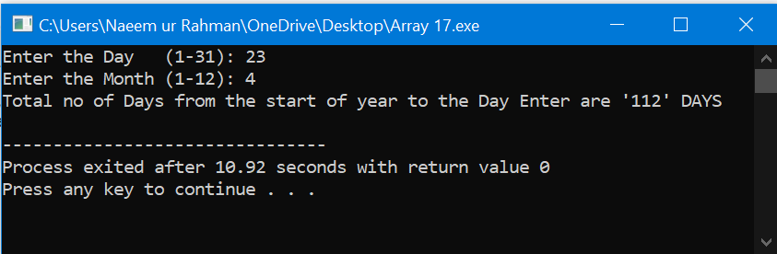

# QUESTION NO #18

Dice Rolled frequency using srand () fun

## Code:

#include <iostream>

#include <stdlib.h>

#include <time.h>

using namespace std;

int main (){ const int size = 7; int D[size]={0};srand(time(0));

for (int a=1;a<6000;a++){ ++D[1+rand()%6] }

cout << "Face"<<setw(15) <<"Frequency"<<endl;

for (int a=1;a<size;a++){

cout << a<< setw(15)<<D[a]<<endl;}

system ("pause");

return 0;}

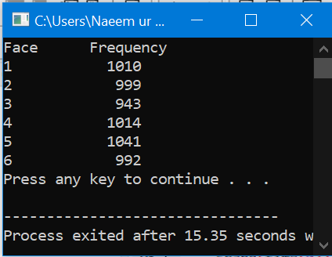

# QUESTION NO #19

Print Astrix using Arrays.

## Code:

#include <iostream>

#include <iomanip>

using namespace std;

int main()

{

unsigned long i,a[i];

cout << "Enter the Number of lines you want to Print : ";cin>>i;

for (int b=0;b<i;b++)

{

cout << b+1 << " Enter : ";cin>>a[b];

}

cout << endl;

for (int c=0;c<i;c++)

{

cout << c+1 << setw(5) << a[c] <<" ";

for (int d=0;d<a[c];d++)

{

cout << "*";

}

cout << endl;

}

return 0;

}

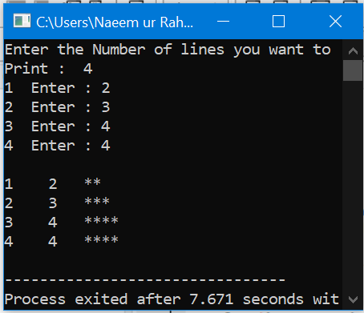

# QUESTION NO #20

C++ Program to Find Transpose of a Matrix using array

## Code:

#include <iostream>

using namespace std;

int main(){

int a[5][5], trans[5][5], r, c, i, j;

cout << "Enter rows of matrix: ";cin >> r;

cout << "Enter columns of matrix: ";cin >> c;

cout<<"Enter Elements to Matrix Below "<<endl;

for(i=0;i<r;i++) {

for(j=0;j<c;++j){

cout<<"Enter a1["<<i<<"]["<<j<<"] Element : ";cin>>a[i][j];

} }

cout <<endl<< " The Entered Matrix is " << endl;

for (i = 0; i < r; ++i){

for (j = 0; j < c; ++j){

cout<<"\t"<<a[i][j]; }

cout<<"\n";}

for(i = 0; i < r; ++i)

for(j = 0; j < c; ++j){

trans[j][i]=a[i][j];}

cout << endl << "Transpose of Matrix : " << endl;

for (i = 0; i < r; ++i){

for (j = 0; j < c; ++j){

cout<<"\t"<<trans[i][j]; }

cout<<"\n\n";}

return 0;}

